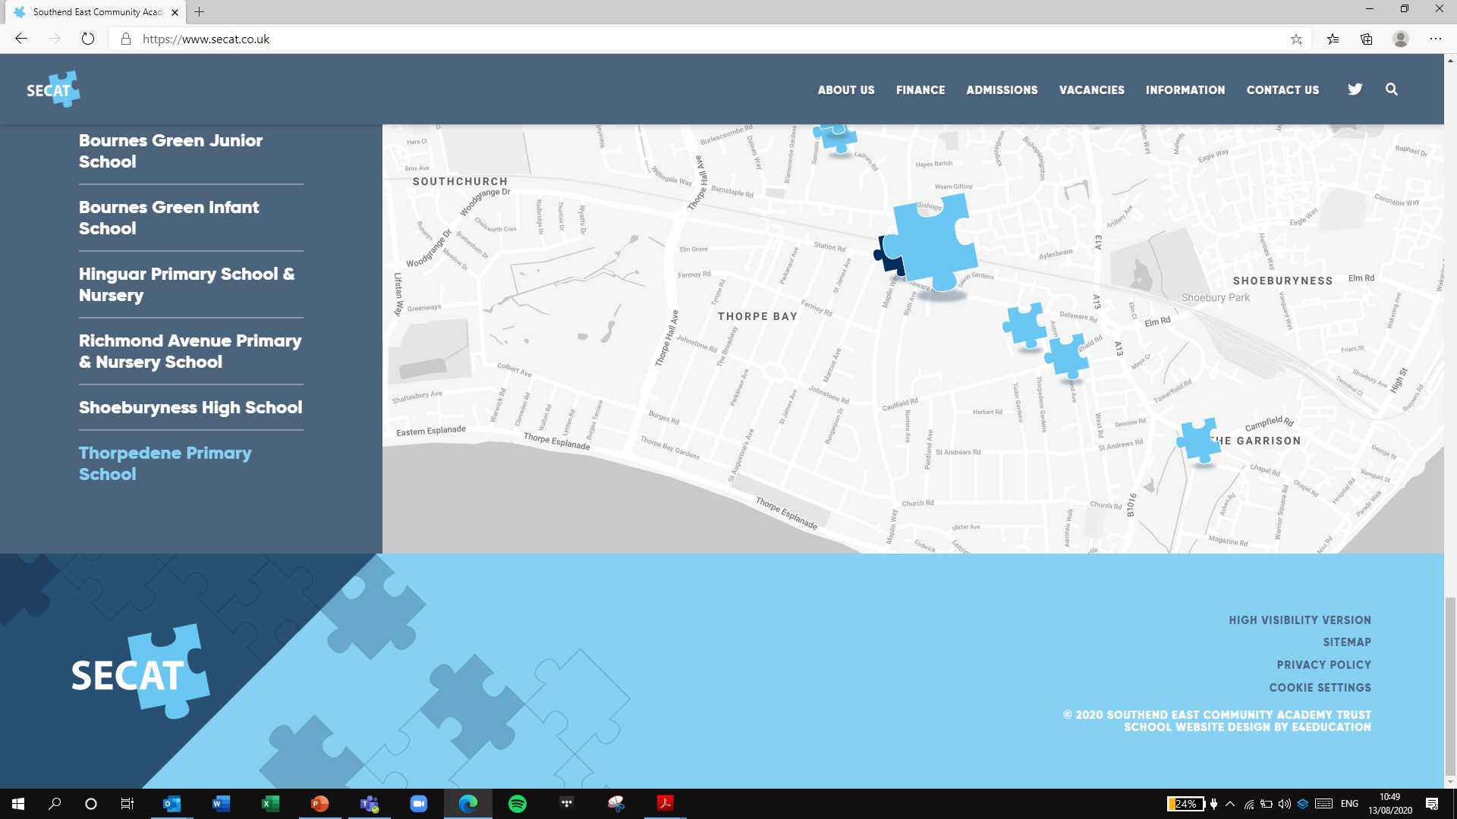

*Building strong schools, Building strong partnerships, Building strong communities*

**SOUTHEND EAST COMMUNITY ACADEMY TRUST**

**Thorpedene Primary School & Nursery**

**CHILD PROTECTION**

**& SAFEGUARDING APPENDIX**

|  |  |
| --- | --- |
| ***Review date*** | ***September 2024*** |
| ***Reviewed by*** | ***S. Carter*** |
| ***Next review date*** | ***September 2025*** |

**1.** **Academy Statement**

***We follow all aspects of statutory safeguarding guidance outlined in the SECAT Trust Child Protection & Safeguarding Policy.***

1.1 To achieve and maintain outstanding safeguarding practice, SECAT is committed to the wellbeing of each child through communicating our vision:

*“Building strong schools, building strong partnerships, building strong communities”*

1.2 The academy aims to ensure that:

* Appropriate action is taken in a timely manner to safeguard and promote children’s welfare.
* All staff are aware of their statutory responsibilities with respect to safeguarding.
* Staff are properly trained in recognising and reporting safeguarding issue.

**2.** **Safeguarding Personnel/Key Contacts**

2.1 **Staff contacts**

Thorpedene Primary and Nursery recognises its responsibilities for safeguarding children and protecting them from harm and understands the importance of trained DSL’s.

|  |  |  |
| --- | --- | --- |
| **Role** | **Name** | **Contact** |
| Designated  Safeguarding Lead (DSL) | Steph Frost  Headteacher | office@thorpedene.secat.co.uk |
| Deputy DSL | Lorraine Wenn  Pupil Welfare Officer | office@thorpedene.secat.co.uk |
| Deputy DSL | Ian Hamilton  Deputy Headteacher | office@thorpedene.secat.co.uk |
| Deputy DSL | Jenny Jackson-Mayo Assistant Headteacher | office@thorpedene.secat.co.uk |
| Deputy DSL | Travis Martinson  Interim Headteacher | office@thorpedene.secat.co.uk |
| Deputy DSL | Sally Carter  SENCo | office@thorpedene.secat.co.uk |

2.2 **DSL**

The DSL is a member of the Senior Leadership Team and takes lead responsibility for child protection and wider safeguarding in the school. This includes online safety and understanding our filtering and monitoring processes on school devices and school networks to keep pupils safe online.

During term time, the DSL will be available during school hours for staff to discuss any safeguarding concerns.

The DSL will be given the time, funding, training, resources, and support to:

* Provide advice and support to other staff on child welfare and child protection matters.
* Take part in strategy discussions and inter-agency meetings and/or support other staff to do so.
* Contribute to the assessment of children.
* Refer suspected cases, as appropriate, to the relevant body (local authority children’s social care, Channel programme, Disclosure and Barring Service, and/or police), and support staff who make such referrals directly.
* Have a good understanding of harmful sexual behaviour.
* Have a good understanding of the filtering and monitoring systems and processes in place at the Trust.

The DSL will also:

* Keep the Headteacher informed of any issues (if the DSL isn’t the Headteacher).
* Liaise with Local Authority Case Managers and designated officers for child protection concerns as appropriate.
* Discuss the local response to sexual violence and sexual harassment with police and Local Authority Children’s Social Care colleagues to prepare the school’s policies.
* Be confident that they know what local specialist support is available to support all children involved (including victims and alleged perpetrators) in sexual violence and sexual harassment, and be confident as to how to access this support.
* Be aware that children must have an ‘appropriate adult’ to support and help them in the case of a police investigation or search.
* The full responsibilities of the DSL and deputies are set out in their job description.

3. **Confidentiality**

3.1 **School Confidentiality and Data Protection**

It is important that confidentiality is upheld in regard to all safeguarding matters. The schools Data Protection Lead (DPL, Deputy headteacher) ensures that all staff are appropriately trained in data protection and safeguarding expectations. The use of CPOMS, an online, secure system for reporting and recording any and all safeguarding information ensures that all documentation on any and all pupils is kept secure and confidential.

In summary:

* Timely information sharing is essential to effective safeguarding.
* Fears about sharing information must not be allowed to stand in the way of the need to promote the welfare, and protect the safety of children.
* The Data Protection Act (DPA) 2018 and UK GDPR do not prevent, or limit, the sharing of information for the purposes of keeping children safe.
* If staff need to share ‘special category personal data’, the DPA 2018 contains ‘safeguarding of children and individuals at risk’ as a processing condition that allows practitioners to share information without consent if: it is not possible to gain consent; it cannot be reasonably expected that a practitioner gains consent; or if to gain consent would place a child at risk.
* Staff should never promise a child that they will not tell anyone about a report of abuse, as this may not be in the child’s best interests.

**4. Recognising Abuse and Taking Action**

4.1Staff, volunteers, trustees, and local Academy Committees must follow the procedures set out in school in the event of a safeguarding issue.

* Report the concern immediately to the DSL/Deputy DSL
* Record all information, in detail, without opinion or bias via CPOMS
* Not share / discuss the concern with any other staff members unless directed by the DSL as part of actions to support a child.

4.2 **FGM**

Keeping Children Safe in Education explains that FGM comprises “all procedures involving partial or total removal of the external female genitalia, or other injury to the female genital organs”.

FGM is illegal in the UK and a form of child abuse with long-lasting, harmful consequences. It is also known as ‘female genital cutting’, ‘circumcision’ or ‘initiation’.

**Any teacher** who either:

* Is informed by a girl under 18 that an act of FGM has been carried out on her; or
* Observes physical signs which appear to show that an act of FGM has been carried out on a girl under 18 and they have no reason to believe that the act was necessary for the girl’s physical or mental health or for purposes connected with labour or birth.

Must immediately report this to the police, personally. This is a mandatory statutory duty, and teachers will face disciplinary sanctions for failing to meet it.

Unless they have been specifically told not to disclose, they should also discuss the case with the DSL and involve children’s social care as appropriate.

**Any other member of staff** who discovers that an act of FGM appears to have been carried out on a **pupil under 18** must speak to the DSL and follow our local safeguarding procedures.

The duty for teachers mentioned above does not apply in cases where a pupil is *at risk* of FGM or FGM is suspected but is not known to have been carried out. Staff should not examine pupils.

4.3 **Sharing of Nudes and Semi-Nudes (sexting)**

If you are made aware of an incident involving the consensual or non-consensual sharing of nude or semi-nude images/videos (also known as ‘sexting’ or ‘youth produced sexual imagery’), you must report it to the DSL immediately.

You must **not**:

* View, copy, print, share, store or save the imagery yourself, or ask a pupil to share or download it (if you have already viewed the imagery by accident, you must report this to the DSL).
* Delete the imagery or ask the pupil to delete it.
* Ask the pupil(s) who are involved in the incident to disclose information regarding the imagery (this is the DSL’s responsibility).
* Share information about the incident with other members of staff, the pupil(s) it involves or their, or other, parents and/or carers.
* Say or do anything to blame or shame any young people involved.

You should explain that you need to report the incident and reassure the pupil(s) that they will receive support and help from the DSL.

4.4 **Reporting Systems for our Pupils**

Where there is a safeguarding concern, we will take the child’s wishes and feelings into account when determining what action to take and what services to provide.

We recognise the importance of ensuring pupils feel safe and comfortable to come forward and report any concerns and/or allegations.

To achieve this we have:

* Worry boxes in place in each class for children to share concerns.
* Senior staff on duty every lunchtime who pupils can come and talk to.
* Key contact posters in every room in the school, with photos of DSLs/DDSLs.
* All staff trained in the use of CPOMS to report and record concerns.
* A member of SLT on gate duty at the beginning and end of every school day.
* Regular safeguard training throughout the year with weekly email updates sent to all staff

5. **Pupils with Special Educational Needs, Disabilities or Health Issues**

5.1We recognise that pupils with SEND or certain health conditions can face additional safeguarding challenges and are 3 times more likely to be abused than their peers. Additional barriers can exist when recognising abuse and neglect in this group. Additional support is available for these pupils via:

* The Inclusion Team, including a SENCO, Pupil Welfare Officer, Learning Mentors and Behavior/SEND LSAs.
* Worry boxes in the classrooms.
* Allocated safe spaces, out of class, for pupils to talk and share in informal spaces
* Use of individual support where necessary, which will be identified on health care plans/ISPs.
* Use of social stories and adapted resources to support pupils understanding and communication.

6. **Looked-After and Previously Looked-After Children**

6.1We will ensure that staff have the skills, knowledge and understanding to keep looked-after children and previously looked-after children safe. In particular, we will ensure that:

* Appropriate staff have relevant information about children’s looked after legal status, contact arrangements with birth parents or those with parental responsibility, and care arrangements.
* There is a named designated teacher for supporting LAC / Post LAC pupils (DSL/AHT).
* This lead works alongside social services to ensure all pupils have appropriate support and that PEP / LAC reviews take place within appropriate time frames.
* The designated teacher also works alongside the DSL / DDSL’s to ensure that any safeguarding concerns regarding these pupils are quickly and effectively responded to as well as ensuring that they are recorded and passed into the appropriate external services.
* The DSL has details of children’s social workers and relevant virtual school heads.

*For further details of how the school works to support safeguarding and manage allegations of abuse, please see the SECAT Child protection & Safeguarding Policy (Specifically Appendixes 3 & 4)*