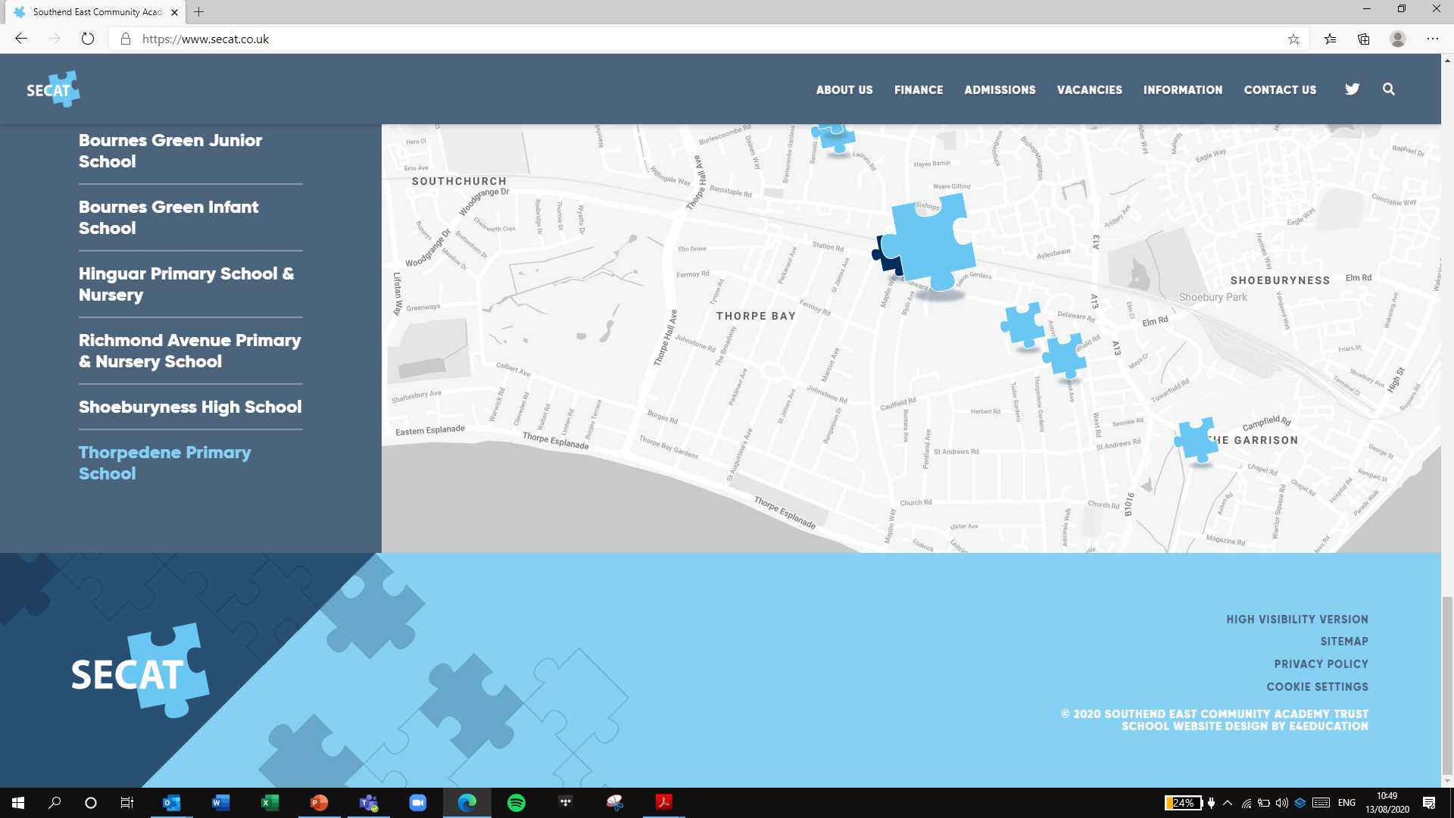

*Building strong schools, Building strong partnerships, Building strong communities*

**SOUTHEND EAST COMMUNITY ACADEMY TRUST**

Charging and Remission Policy Appendix

Thorpedene Primary School & Nursery

|  |  |
| --- | --- |
| **Review date** | September 2024 |
| **Reviewed by** | S. Frost |
| **Next review date** | September 2025 |

7. **Voluntary Contributions:**

* Day and part day educational visits. For visits occurring during school time the school will invite a voluntary contribution from parents to meet the cost of the visit. Please note, where voluntary contributions are insufficient to cover the costs involved, the visit or activity may be cancelled. The maximum charge for any day trip will be £25.00.
* Visiting groups (e.g. theatre groups) or speakers who may charge the school for their services. Please note, where voluntary contributions are insufficient to cover the costs involved, the visit or activity may be cancelled.
* School Performances. Donations to designated charities.
* Non-uniform days. Up to £1.00 (for various Charities and school resources)

8. **Activities we charge for:**

* Instrumental music tuition.

School Music Teachers may provide lessons during the school day and parents are requested to pay a subsidised amount towards the cost of these lessons.

* Residential visits within school time.

The cost of educational activities and travel may be covered by voluntary contributions as above. Where there are not enough voluntary contributions to make the activity possible, and there is no way to make up the shortfall, then it will be cancelled.

* School Lunches.

Currently free for Reception, Years 1 and 2.

£2.80 per meal for Years 3 - 6.

Christmas lunch is charged at £2.80 (Years 3 - 6).

9. **Extra-curricular clubs led by external providers:**

* Music Festivals at local venues